From: https://www.zerohedge.com/news/2018-02-10/pentagons-nuclear-doctrine-retrograde-and-reckless
Echoed from: https://www.strategic-culture.org/news/2018/02/09/pentagon-nuclear-doctrine-retrograde-and-reckless.html

Pentagon's Nuclear Doctrine – Retrograde and Reckless

by Tyler Durden
Sat, 02/10/2018 - 23:15
78
SHARES
Via The Strategic Culture Foundation,
In its latest Nuclear Posture Review (NPR), the American Pentagon declares at one point in the document that the Cold War is long over. Apart from that fleeting mention, however, one would think from reading the entire review that the Cold War, for Washington, has never been so palpable.
[NPR was called QDR (Qadrennial Defense Review). –FNC]
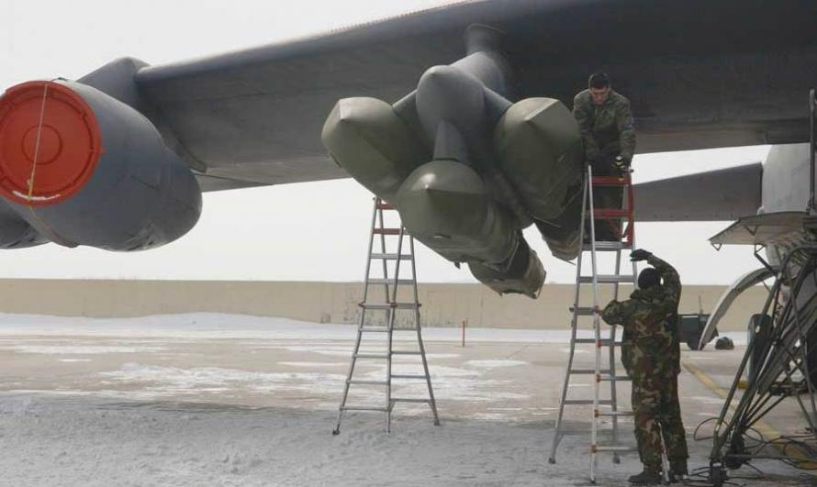
It is a fear-laden document, relentlessly portraying the world as fraught with existential danger to US national security.
Russia and China, as with two other recent strategic policy papers out of Washington, are again painted as adversaries who must be confronted with ever-greater US military power.
The latest NPR asserts that since the last such review in 2010, “America confronts an international security situation that is more complex and demanding than any since the end of the Cold War.”
It is clear from reading the 74-page document that Russia and China are the main source of security concern for the Pentagon – albeit the reasons for the concern are far from convincing. Indeed one might say downright alarmist.
Washington accuses Russia and China of pursuing nuclear weapons development which is threatening. It accuses Russia in particular of violating arms controls treaties and threatening American allies with its nuclear arsenal. There are several other such unsubstantiated claims made by the Pentagon in the document.
Russia and China responded by condemning the aggressive nature of the Pentagon’s latest doctrine, as they have done with regard to two other recent strategic papers published by the Trump administration.
It is deplorable that Washington seems to go out of its way to portray the world in such bellicose terms. The corollary of this attitude is the repudiation of diplomacy and multilateralism.
Washington, it seems, is a hostage to its own imperative need to generate a world of hostile relations in order to justify its rampant militarism, which is, in turn, fundamental to its capitalist economy.
The lamentable, even criminal, danger of this strategy is that it foments unnecessary tensions and animosity in world relations. Russia and China have repeatedly called for normal, multilateral relations. Yet, remorselessly, Washington demonizes the two military powers in ways that are retrograde and reckless.
The Pentagon’s latest nuclear doctrine goes even further in its provocations. Based on dubious accusations of Russia’s threatening behavior (“annexation of Crimea”, “aggression in Ukraine”), the Pentagon has declared it will rely more on nuclear force for “deterrence”.
That can be taken as a warning that Washington is, in effect, lowering its threshold for deploying nuclear weapons. It overtly states that it will consider use of nuclear weapons to defend American interests and allies from “nuclear and conventional threats”. The language is chilling. It talks about inflicting “incalculable” and “intolerable” costs on “adversaries”. This is nothing short of Washington terrorizing the rest of the world into conforming to its geopolitical demands.
Another sinister development is that Washington has now declared that it will be acquiring “low-yield” nuclear weapons. These so-called “mini-nukes” will again lower the threshold for possible deployment of nuclear warheads in the misplaced belief that such deployment will not escalate to strategic weapons.
What’s disturbing is that the US is evidently moving toward a policy of greater reliance on nuclear force to underpin its international power objectives. It is also broadening, in a provocative and reckless way, what it considers “aggression” by other adversaries, principally Russia. Taken together, Washington is increasingly setting itself on a more hostile course.
Some 57 years ago, in 1961, then US President Dwight Eisenhower gave a farewell address to the nation in which he issued a grave forewarning about the growing control of the “military-industrial complex” over American life. Back then, the American military-industrial complex could disguise its insatiable appetite with the pretext of the Cold War and the “Soviet enemy”.

Ike Farwell Address Papers of the Presidents, .docx, Papers of the Presidents, .htm, Television .

Today, the American federal government spends about $700 billion a year on military – over half its discretionary budget. The US spends more on military than at any time during the Cold War – in constant dollar terms.
The US military-industrial complex has become a voracious monster way beyond anything that Eisenhower may have feared. It is no longer a threat merely to American life. It is a threat to the life of the entire planet.
Objectively, the US has no foreign enemy endangering its existence; neither Russia nor China. Not even North Korea, despite its anti-American rhetoric, poses a direct threat to the US.
The Pentagon – on behalf of the military-industrial complex – is stretching credulity when it depicts the world as a more threatening place. Fingering Russia and China is absurd.
In order to try to shore up its scare-mongering with a semblance of credibility, the Pentagon is escalating the rhetoric about nuclear weapons and the need to deploy them. There is no objective justification for this nuclear posturing by the US, only as a way to dramatize alleged national security fears, in order to keep the military-industrial racket going.
The despicable danger from this retrograde Cold War strategy is that the US is recklessly pushing the world toward war and possibly nuclear catastrophe.
Fortunately, Russia and China have highly developed military defenses to keep American insanity in check. Nevertheless, American belligerence is pushing the world to combustible tensions.
The problem is that American rulers have become a rogue state. The American people need to somehow sack their rogue rulers and their military madness, and return the nation to a democratic function.
Until then, Russia and the rest of the world must be on guard.

